Field Visit Report

Tangail District
Date: 6 and 7 and 19 - 21 April 2022

Submitted by:
Dr. Md. Emdadul Haque, National Consultant Md. Azmal Kabir, National Consultant

Submitted to:
Dr. Mohd. Shahadt Hossain Mahmud
Director General (Additional Secretary)
Health Economics Unit (HEU), Health Services Division Ministry of Health and Family Welfare (MoHFW)
Ansari Bhaban (3rd floor), 14/2 Topkhana road, Dhaka-1000

And
Dr. Md. Nurul Amin
Director (Research)
Health Economics Unit (HEU), Health Services Division Ministry of Health and Family Welfare (MoHFW)
Ansari Bhaban (3rd floor), 14/2 Topkhana road, Dhaka-1000

Name of Hospital: Upazila Health Complex Delduar, Tangail
Date of Baseline assessment: 19/04/22.
Assessment Team members:

Sl. | Name | Designation
1. | Mr. Md. Azmal Kabir | National Consultant (SSK)
2. | Dr. Md. Emdadul Haque | National Consultant (SSK)

- Admistrative discussion: Discussion with UH&FPO and RMO about the activities of SSK out sourcing workers –working in that UHC .The hospital 31 bedded .Many of the worker not present in time. Some of the doctors reside within the hospital campus. The security system of the hospital is very weak.
- Discussion: With all the doctors of the hospital about our objectives of the visit and idea sharing about performance of the hospital and status of the health service system strengthening and activities Chowgacha UHC model.
- Visit of the emergency, outdoor & indoor: We visited the hospital campus with UH&FPO and RMO
  - Campus was not so clean, we advised to remove the unwanted posters, garbage and to improve the waste management system.
  - Emergency management system is weak. Outdoor is disorganized.
  - Indoor: No labour word, conference room, OT is not functioning, labor room is diorganised.50 bedded building is completed and handed over, but having no administrative order, diet, medicine or human resources.
- Conclusions: The heath complex needs extensive intervention both by local a high officials are involvement.

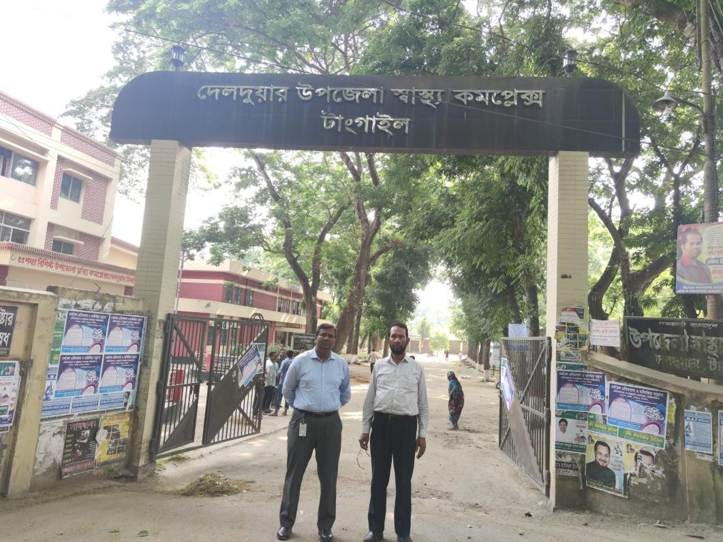

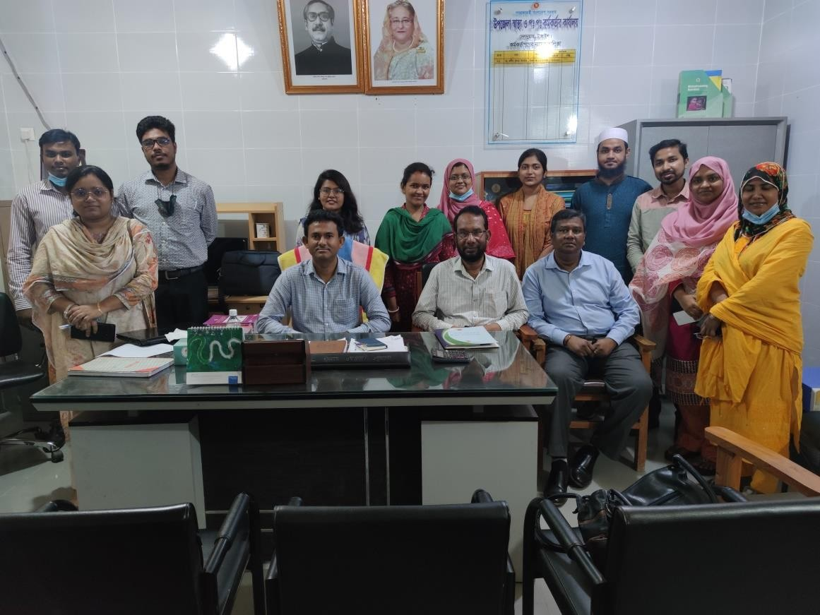

A comparison of the Criteria Chowgacha UHC model with Delduar UHC.

Sl.  No. | Criteria of Chowgacha Model | Very good | Good | Poor
1. | Birth &Death recording |  | +
2. | Health education Corner. |  |  | +
3. | Cleanliness & Beatification |  | +
4. | Cycle-Van stand close to the main gate. |  | +
5. | Display of the activities of the UHC  (Field &health complex.) |  |  | +
6. | Blood donor list in Pathology dept. |  |  | +
7. | Separation of patient in OPD &IPD(Male,Female,Under5 & EOC) |  | +
8. | IMCI-Corner. |  | +
9. | ANC&PNC Corner |  | +
10. | NCD-Corner |  | +
11. | EPI & Breast Feeding Corner |  |  | +
12. | ORT &Nutrition Corner |  |  | +
13. | Waste management |  | +
14. | Moral based environment. |  | +
15. | Implementation of 5S KAIZEN |  |  | +
16. | Community participation |  |  | +
17. | Reception Desk | +
18. | Hospital Protocol board. |  |  | +
19. | Display of meeting schedule |  |  | +
20. | Knowledge about 7th5 yr. plan & SDG. |  |  | +
21. | Display of information in every section |  |  | +
22. | VIA Service |  | +
23. | Infection prevention activities. |  | +
24. | Relation with local administration, OC &  community leaders. |  | +
25. | Positive media coverage |  | +
26. | Publication of Annual Report. |  |  | +
27. | Position in HSS score of MIS in Feb-22 |  |  | 212th
28 | Video on UHC. |  |  | +

Name of Hospital: UHC Sadar, Tangail.

Date of Baseline assessment: 19/04/22.at 1PM. Assessment Team members:
Sl. | Name | Designation
1. | Mr. Md. Azmal Kabir. | National Consultant (SSK)
2. | Dr. Md. Emdadul Haque. | National Consultant (SSK)

- Admistrative discussion: Discussion with UH&FPO and MO (DC) about how implement the activities of SSK in Sadar Upazilla, Tangail. There is no hospital for indoor –only outdoor as it is also School Health Clinic. Only 5 MOs and 4 Midwifes are working in the clinic.
- Discussion: According to the observation of the UH&FPO and other MOs in door services for the population of the upazilla is inadequate because of over loaded district hospital. The bed occupancy rate of general hospital is >300%. So the SSK patients are not honoured properly. If it would possible to create 50 bedded UHC for indoor and outdoor service, it will be very helpful for the sadar upazilla and pouroshova SSK patient. It would be recognition for them.
Starting of Medical College Hospital may decrease the over load of the general hospital.

Conclusions: 50 bedded new hospital infrastructure is needed for sadar upazilla and pouroshova for IPD and OPD.

µwgK bs | c`ex | gÄyixK…Z c` | c~ibK…Zc` | k~b¨c`
1 | Dc‡Rjv ¯^v¯’¨ I ct ct Kg©KZ©v | 01 | 01
2 | Rywbqi Kbt Gt | 01 | 01
3 | ‡gwW‡Kj Awdmvi | 06 | 05 | 01
4 | mnKvix mvR©b | 0৭ | 0৫ | ০২
৫ | × Lফ (NLe ´ ২ <T ) | ০৫ | ০৫ | ০০
 | me©‡gvU | ২০ | 1৭ | 0৩

Kg©Pvixe„›`

µwgK bs | c`ex | gÄyixK…Z c` | c~ibK…Zc` | k~b¨c`
1 | cÖavbmnKvix Kvg wnmve iøK | 01 | 01 | -
2 | cwimsL¨vbwe` | 01 | 0০ | ০১
3 | ‡óvi wKcvi | 01 | 01 | -
4 | K¨vwkqvi | 01 | 0০ | ০১
5 | Awdm mnKvix Kvg-Kw¤úDUvi Acv‡iUi | 01 | 01 | -
6 | Gg wU(j¨vet) | 01 | 01 | -
7 | m¨v‡bUvix BÝ‡c±i | 01 | 01 | -
8 | Gg wU (B wc AvB) | 01 | 01 | -
9 | wU Gj wm G | 01 | 01 | -
10 | Gm G wm Gg I | 12 | 12 | -
11 | dvg©vwwmó | 05 | 05 | -
12 | ¯^v¯’¨ cwi`k©K | 3 | 03 | -
13 | mnKvix ¯^v¯’¨ cwi`k©K | 09 | 09 | -
14 | ¯^v¯’¨ mnKvix | 45 | ৩১ | ১৪
15 | wm GBP wm wc | 4০ | ৪০ | 0০
16 | Gg Gj Gm Gm | 09 | ৪ | ৫
 | me© †gvU = | 13২ | ১১১ | ২১

Name of Hospital: Ghatail Upazilla Health Complex

Date of Assessment: 20/04/22. At 9AM. Assessment Team members:
Sl. | Name | Designation
1. | Mr.Azmal Kabir. | National Consultant (SSK)
2. | Dr.Md.Emdadul Haque. | National Consultant (SSK)

- Admistrative discussion: Discussion with UH&FPO and RMO about all the activities Chowgacha Model by power point presentation. Many of the worker present in time.
- Visit of the emergency, outdoor & indoor: We visited the hospital campus with UH&FPO and RMO
  - Campus was clean attractive, we advised to remove the unwanted posters and more beatification.
  - Outdoor:
    - There are trained human resources for eye, so advised for opening an eye corner.
    - IMCI Corner: There is a pediatric consultant in outdoor. Advised for nutritional assessment for Under 5 children.
*ANC Corner is disorganized, advised for improvement.
    - ECG investigation is going on effectively, but need report is not done. but it is possible because cardiologist is there.
    - Health Education Corner: We have selected a site for corner and advised for starting by audio-visual system.
    - Safe blood transfusion is very essential for maternal health. They have no donor list. We have advised for prepare a donor list in the laboratory for emergency purpose.
  - Indoor : Labour room is disorganized. Advised for organized labour room, and maintaining sterility.
- Meeting: A meeting of community support group is going on. We participate with the program and discussed with them about maternal health. Nearly 50 attendances were present there.
- Conclusions: Dr. Saifur UH&FPO has the leadership quality and team building capacity. The heath complex needs intervention to develop a model for these region. So special support is needed from HEU.

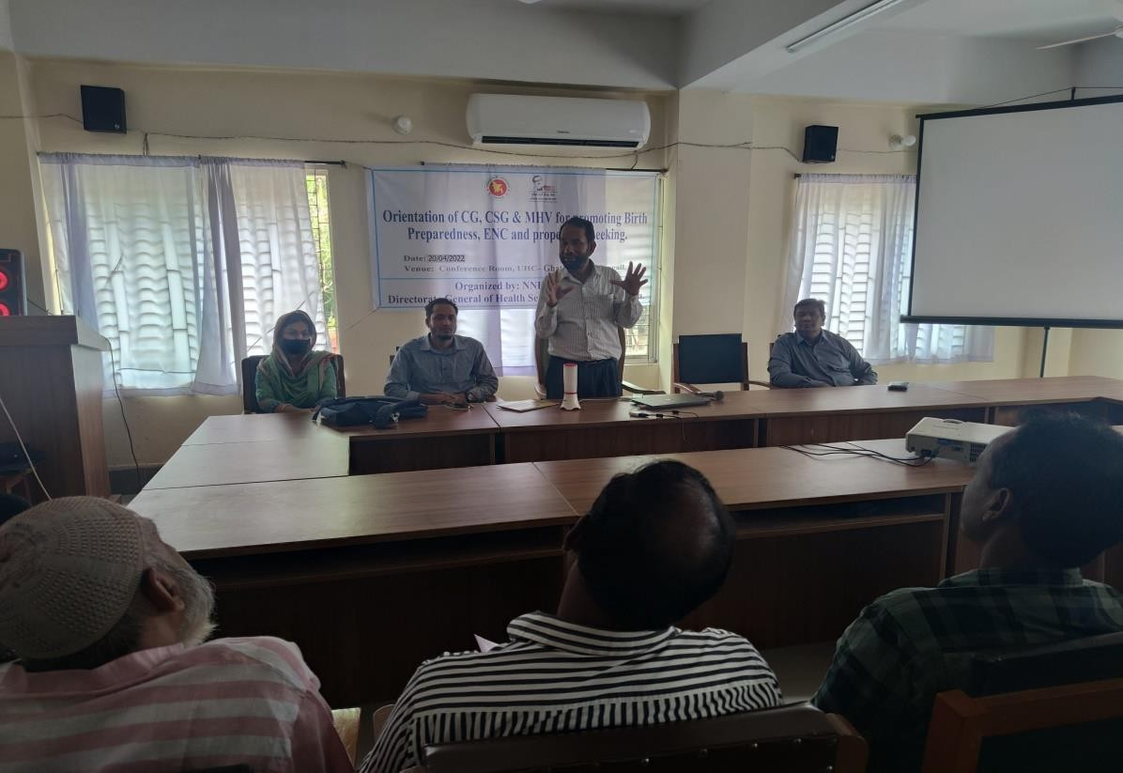

A comparison of the Criteria Chowgacha UHC model with Ghatail UHC.

Sl.No. | Criteria of Chowgacha Model | Very good | Good | Poor
1. | Birth &Death recording |  | +
2. | Health education Corner. |  |  | +
3. | Cleanliness & Beatification |  | +
4. | Cycle-Van stand close to the main  gate. |  | +
5. | Display of the activities of the UHC  (Field &health complex.) |  |  | +
6. | Blood donor list in Pathology dept. |  |  | +
7. | Separation of patient in OPD  &IPD(Male,Female,Under5 & EOC) |  | +
8. | IMCI-Corner. |  | +
9. | ANC&PNC Corner |  | +
10. | NCD-Corner |  | +
11. | EPI & Breast Feeding Corner |  |  | +
12. | ORT &Nutrition Corner |  |  | +
13. | Waste management |  | +
14. | Moral based environment |  | +
15. | Implementation of 5S KAIZEN |  | +
16. | Community participation |  | +
17. | Reception Desk | +
18. | Hospital Protocol board. |  |  | +
19. | Display of meeting schedule |  |  | +
20. | Knowledge about 7th5 yr. plan &  SDG. |  |  | +
21. | Display of information in every  section |  |  | +
22. | VIA Service |  | +
23. | Infection prevention activities. |  | +
24. | Relation with local administration,  OC & community leaders. |  | +
25. | Positive media coverage |  | +
26. | Publication of Annual Report. |  |  | +
27. | Position in HSS score of MIS in Feb-  22 |  | 112th
28 | Video on UHC. |  | +

Name of Hospital: UHC Modhupur, Tangail.

Date of Baseline assessment: 07/04/22.AT 11-30AM. Assessment Team members:
Sl. | Name | Designation
1. | Mr. Md. Azmal Kabir. | National Consultant (SSK)
2. | Dr. Md. Emdadul Haque. | National Consultant (SSK)

- Admistrative discussion: Discussion with UH&FPO, RMO and other MOs about basic information of the UHC and activities of SSK program .The hospital 50 bedded. 100 bedded building is completed and handovered, but having no administrative approval, diet, medicine or human resources. Some of the doctors reside within the hospital campus. According to the status of HSS score the position of Modhupur UHC is 30th position among 422 UHC of the country in Feb-22.
- Discussion: With all the doctors of the hospital about our objectives of the visit and idea sharing about performance of the hospital and activities Chowgacha UHC model.
- Visit of the emergency, outdoor & indoor: We visited the hospital campus with UH&FPO and RMO
  - Campus was clean &beautiful. Cycle stand is close to the main gate.
  - Emergency management system is effective. Lab service is well organized and running effectively. Digital X-Ray system is functioning
  - Outdoor service is organized. There is health education system but not effectively running.
  - Indoor: No labour word, OT is functioning but disorganized an anesthesiologist is working but gynecologist is working 3 days in a week. She is in deputation in sadar hospital, Tangail.
- Conclusions: The activities of the health complex are good but need more interventions.

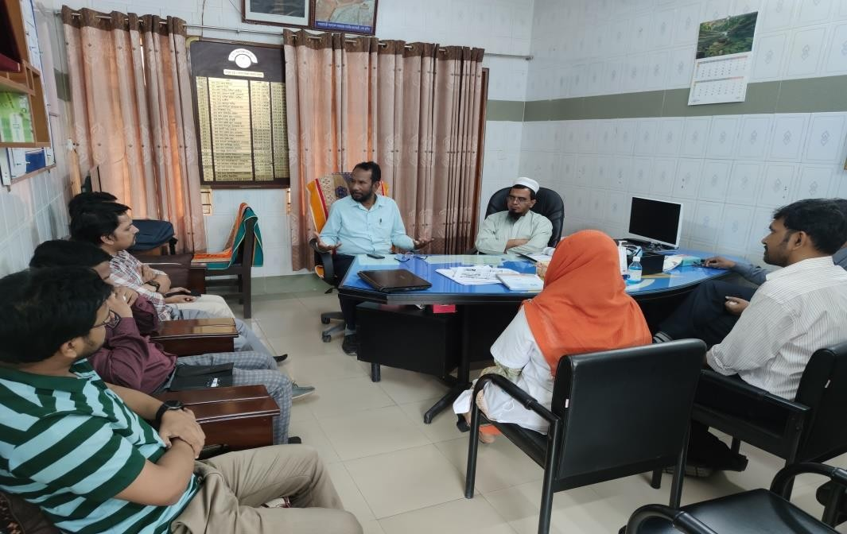

A comparison of the Criteria Chowgacha UHC Model with Modhupur UHC.

Sl.  No. | Criteria of Chowgacha Model | Very good | Good | Poor
1. | Birth &Death recording |  | +
2. | Health education Corner. |  |  | +
3. | Cleanliness & Beatification |  | +
4. | Cycle-Van stand close to the main gate. |  |  | +
5. | Display of the activities of the  UHC(Field &health complex.) |  |  | +
6. | Blood donor list in Pathology dept. |  |  | +
7. | Separation of patient in OPD &IPD  (Male,Female,Under5 & EOC) |  | +
8. | IMCI-Corner. |  | +
9. | ANC&PNC Corner |  | +
10. | NCD-Corner |  | +
11. | EPI & Breast Feeding Corner |  |  | +
12. | ORT &Nutrition Corner |  |  | +
13. | Waste management |  | +
14. | Moral based environment |  | +
15. | Implementation of 5S KAIZEN |  |  | +
16. | Community participation |  |  | +
17. | Reception Desk | +
18. | Hospital Protocol board. |  |  | +
19. | Display of meeting schedule |  |  | +
20. | Knowledge about 7th5 yr. plan & SDG. |  |  | +
21. | Display of information in every section |  |  | +
22. | VIA Service |  | +
23. | Infection prevention activities. |  | +
24. | Relation with local administration, OC  & community leaders. |  | +
25. | Positive media coverage |  | +
26. | Publication of Annual Report. |  |  | +
27. | Position in HSS score of MIS in Feb-22 | 30th
28 | Video on UHC. |  |  | +

Name of Hospital : UHC Nagarpur, Tangail.

Date of Baseline assessment: 21/04/22.AT 11-30AM. Assessment Team members:
Sl. | Name | Designation
1. | Mr. Md. Azmal Kabir | National Consultant (SSK)
2. | Dr. Md. Emdadul Haque | National Consultant (SSK)

- Admistrative discussion: Discussion with UH&FPO, RMO and other MOs about basic information of the UHC and activities of SSK program .The hospital 50 bedded .Some of the doctors reside within the hospital campus. According to the status of HSS score the position of Nagarpur UHC is 237 ^{th} position among 422 UHC of the country in Feb-22.
- Discussion: With all the doctors of the hospital about our objectives of the visit and idea sharing about performance of the hospital and activities Chowgacha UHC model.
- Visit of the emergency, outdoor & indoor: We visited the hospital campus with UH&FPO and RMO

  - Campus was clean & beautiful. Cycle stand is close to the main gait.
  - Emergency management system is effective. Lab service is well organized and running effectively. X-Ray system is functioning
  - Outdoor service is organized. There is no health education system.
  - Indoor: labour word, OT is nonfunctioning but disorganized. No anesthesiologist and no gynecologist .A medical officer having FCPS(Surgery) can perform C-Section but needed anesthesiologist.
*We participate in a meeting organized by UH&FPO .All the CHCP of the upazilla of Nagarpur were present there .We discuss there about maternal health and SSK activities.
** Before visit to the UHC we supervise the activities of the field worker and observe how to register the beneficiaries of SSK in Nagarpur union.
- Conclusions: The activities of the health complex are good but need more interventions.

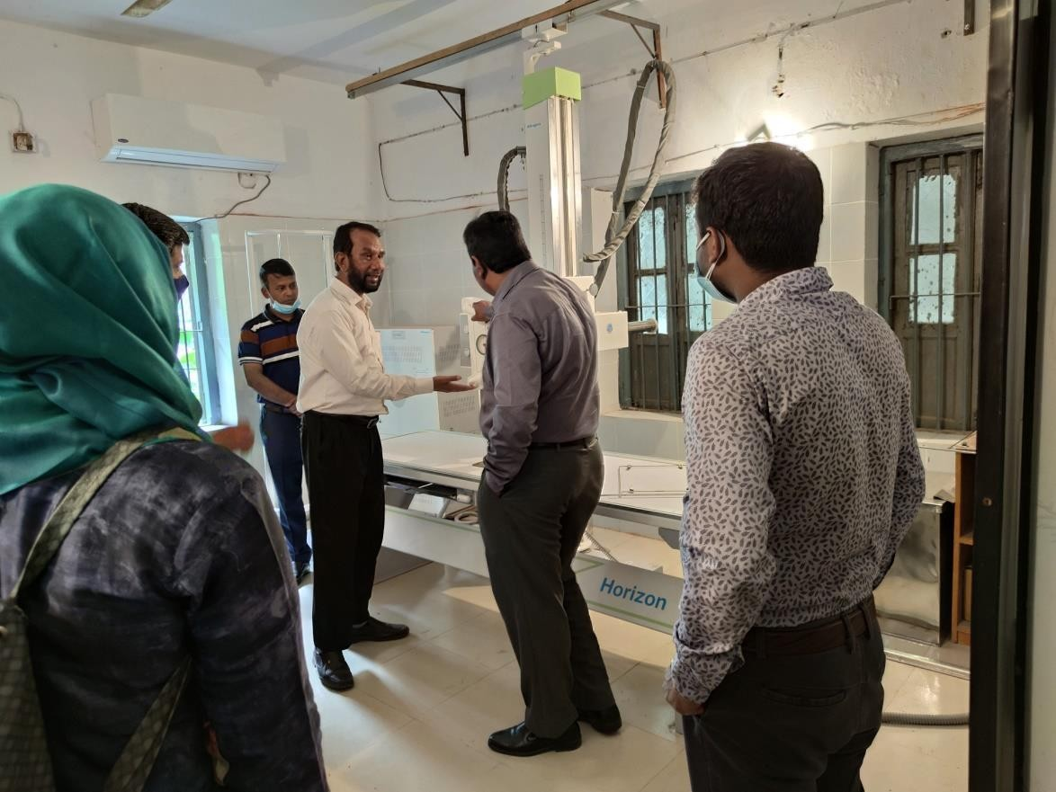
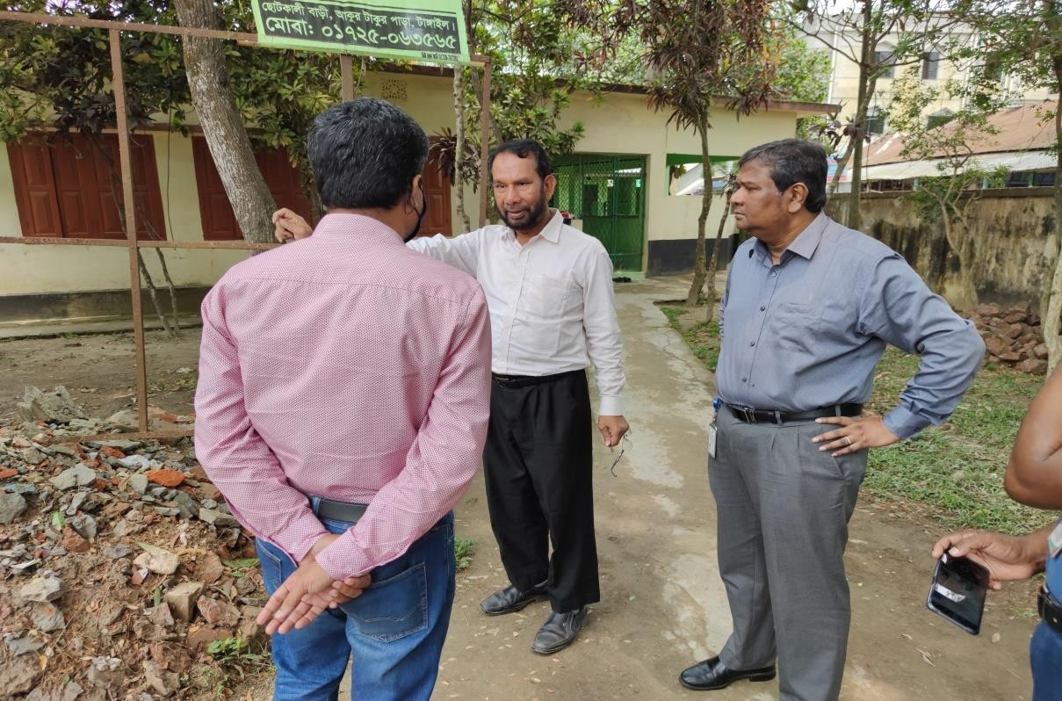

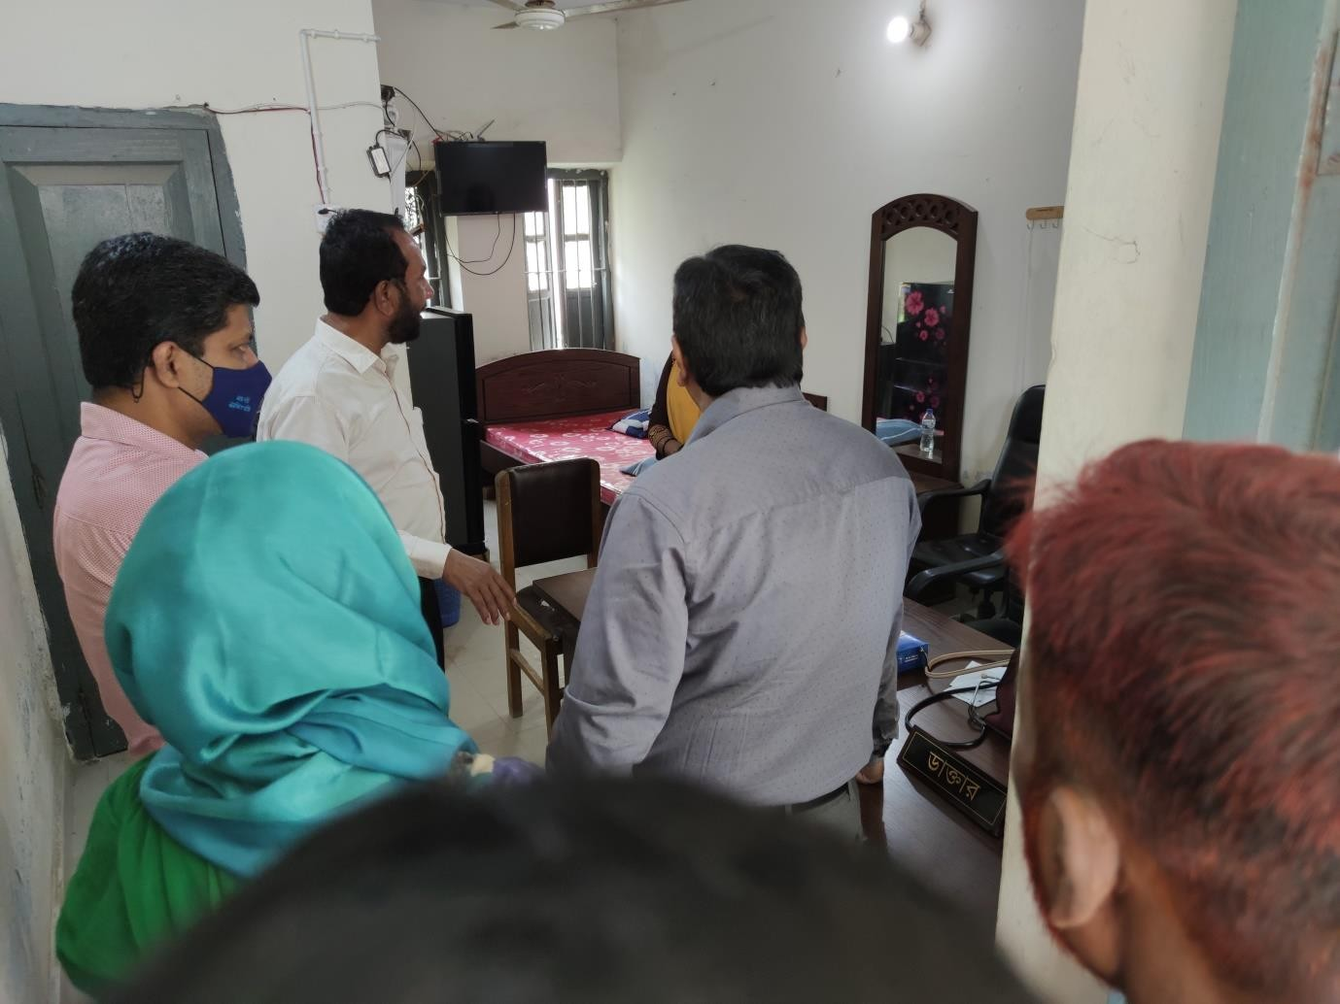

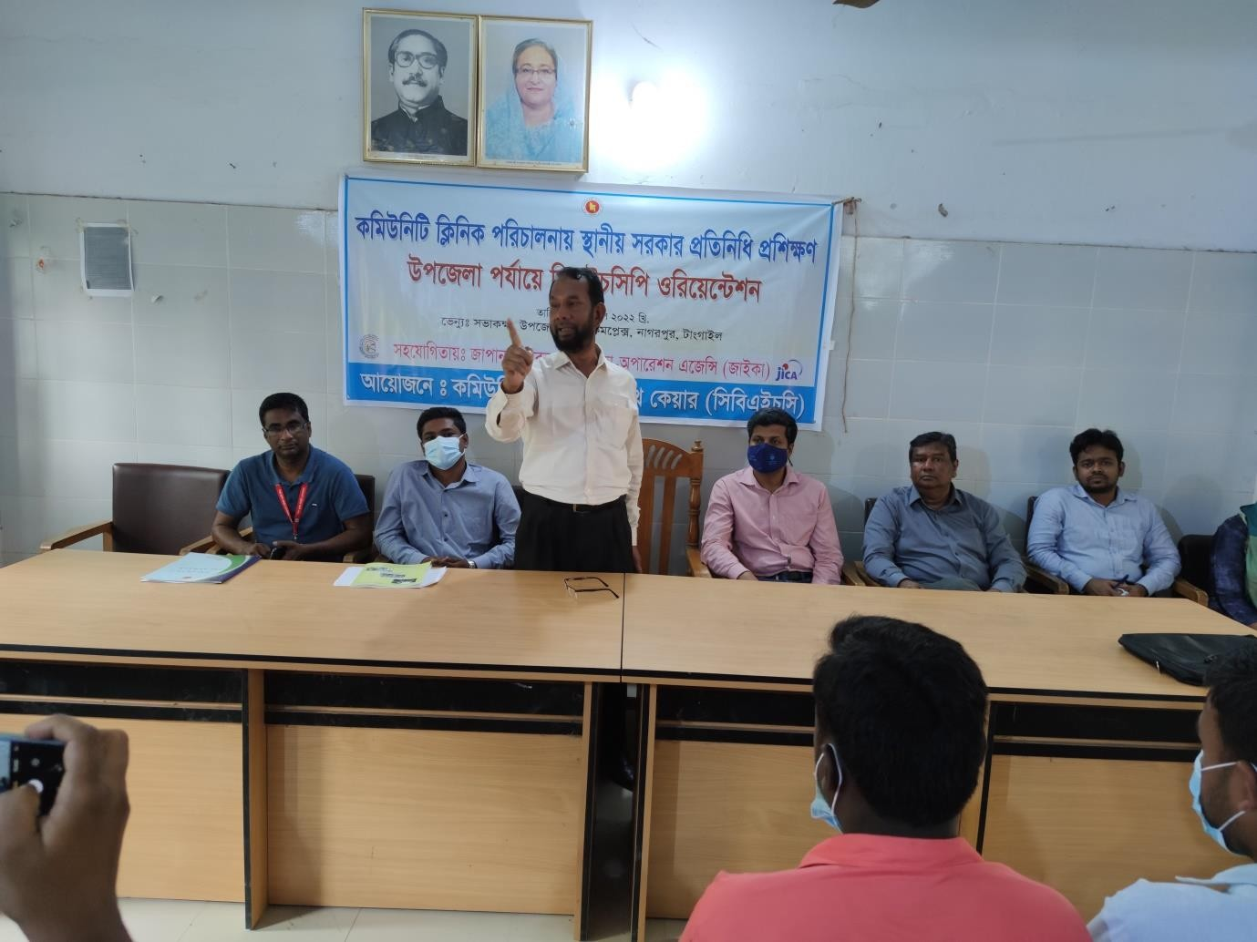

A comparison of the Criteria Chowgacha UHC Model with UHC.

Sl.No. | Criteria of Chowgacha Model | Very good | Good | Poor
1. | Birth &Death recording |  | +
2. | Health education Corner. |  |  | +
3. | Cleanliness & Beatification |  | +
4. | Cycle-Van stand close to the main gate. |  | +
5. | Display of the activities of the UHC(Field &health complex.) |  |  | +
6. | Blood donor list in Pathology dept. |  | +
7. | Separation of patient in OPD  &IPD(Male,Female,Under5 & EOC) |  | +
8. | IMCI-Corner. |  | +
9. | ANC&PNC Corner |  | +
10. | NCD-Corner |  | +
11. | EPI & Breast Feeding Corner |  |  | +
12. | ORT &Nutrition Corner |  |  | +
13. | Waste management |  | +
14. | Moral based environment. |  | +
15. | Implementation of 5S KAIZEN |  | +
16. | Community participation |  |  | +
17. | Reception Desk | +
18. | Hospital Protocol board. |  |  | +
19. | Display of meeting schedule |  |  | +
20. | Knowledge about 7th5 yr .plan & SDG. |  |  | +
21. | Display of information in every section |  |  | +
22. | VIA Service |  | +
23. | Infection prevention activities. |  | +
24. | Relation with local administration, OC  & community leaders. |  | +
25. | Positive media coverage |  | +
26. | Publication of Annual Report. |  |  | +
27. | Position in HSS score of MIS in Feb-  22. |  |  | 237th
28 | Video on UHC. |  |  | +

Name of Hospital: UHC Gopalpur, Tangail.

Date of Baseline assessment: 07/04/22.AT 11-30AM. Assessment Team members:
Sl. | Name | Designation
1. | Mr.Azmal Kabir. | National Consultant (SSK)
2. | Dr. Md. Emdadul Haque. | National Consultant (SSK)

- Administrative discussion: Discussion with Dr. Alim-Al Razi( UH&FPO) ,RMO and other MOs about basic information of the UHC and activities of SSK program .The hospital 50 bedded .Some of the doctors reside within the hospital campus. According to the status of HSS score the position of Gopalpur UHC is125th position among 422 UHC of the country in Feb-22.
- Discussion: With all the doctors of the hospital about our objectives of the visit and idea sharing about performance of the hospital and activities Chowgacha UHC model.
- Visit of the emergency, outdoor & indoor: We visited the hospital campus with UH&FPO and RMO

  - Campus was clean &beautiful. Cycle stand is not close to the main gate.
- Before visit to the UHC we participate in a meeting with the data collector about the registration of the beneficiaries of SSK in Gopalpur Pouroshova.

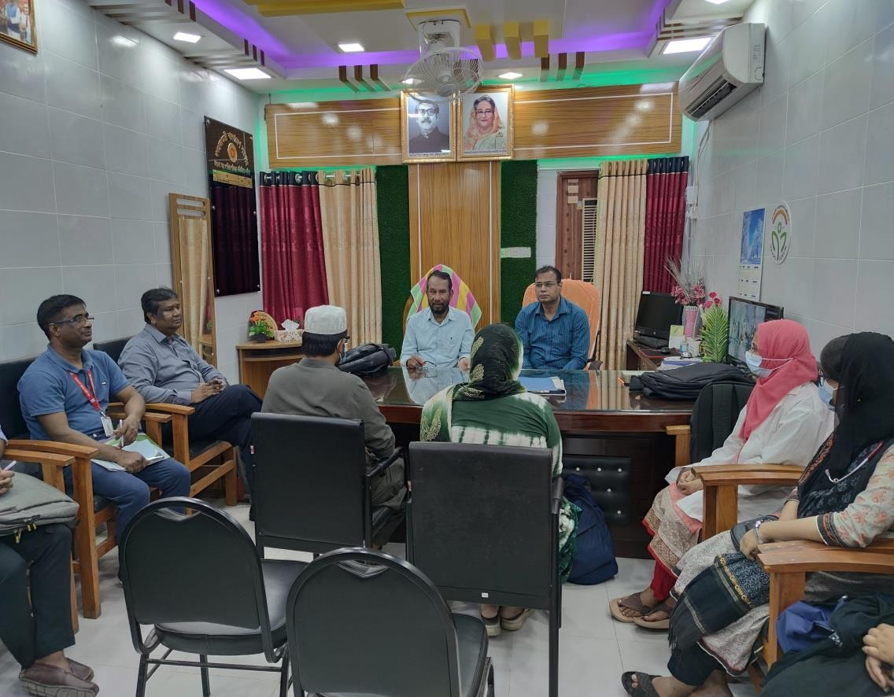
Meeting with doctors at UHFPO office, Gopalpur UHC
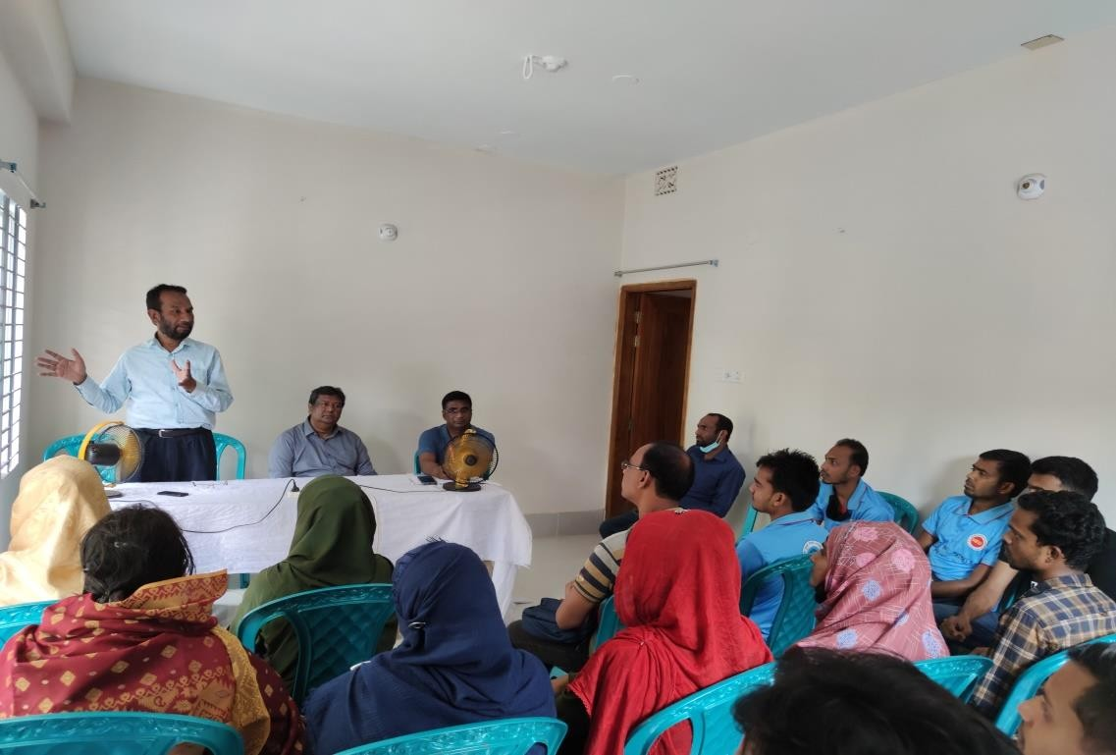
Meeting with BPL data collector at Gopalpur

Name of Hospital: UHC Kalihati, Tangail.

Date of Baseline assessment: 07/04/22.AT 9-30AM. Assessment Team members:
Sl. | Name | Designation
1. | Mr. Md. Azmal Kabir. | National Consultant (SSK)
2. | Dr. Md. Emdadul Haque. | National Consultant (SSK)

- Administrative discussion: Discussion with UH&FPO, RMO and other MOs about basic information of the UHC and activities of SSK program .The hospital 50 bedded. Some of the doctors reside within the hospital campus. The status of HSS score the position of Kalihati UHC is 39th position among 422 UHC of the country.
- Discussion: With all the doctors of the hospital about our objectives of the visit and idea sharing about performance of the hospital and activities Chowgacha UHC model.
- Visit the emergency, outdoor & indoor: We visited the hospital campus with UH&FPO and RMO
  - Campus was clean &beautiful. Cycle stand is close to the main gate.
  - Emergency management system is effective. Lab service is well organized and running effectively .Digital X-Ray system is not functioning
  - Outdoor service is organized. There is no health education system.
  - Indoor: No labour word, OT is functioning but diorganised.an anesthesiologist is working but gynecologist is working 3 days a week. She is in deputation in sadar hospital, Tangail.
**We have motivated a client of SSK for C-section. The guardian was not interested to perform C-Section in the UHC, though she has a strong indication of C-Section.
- Conclusions: The activities of the health complex are good but need more interventions.

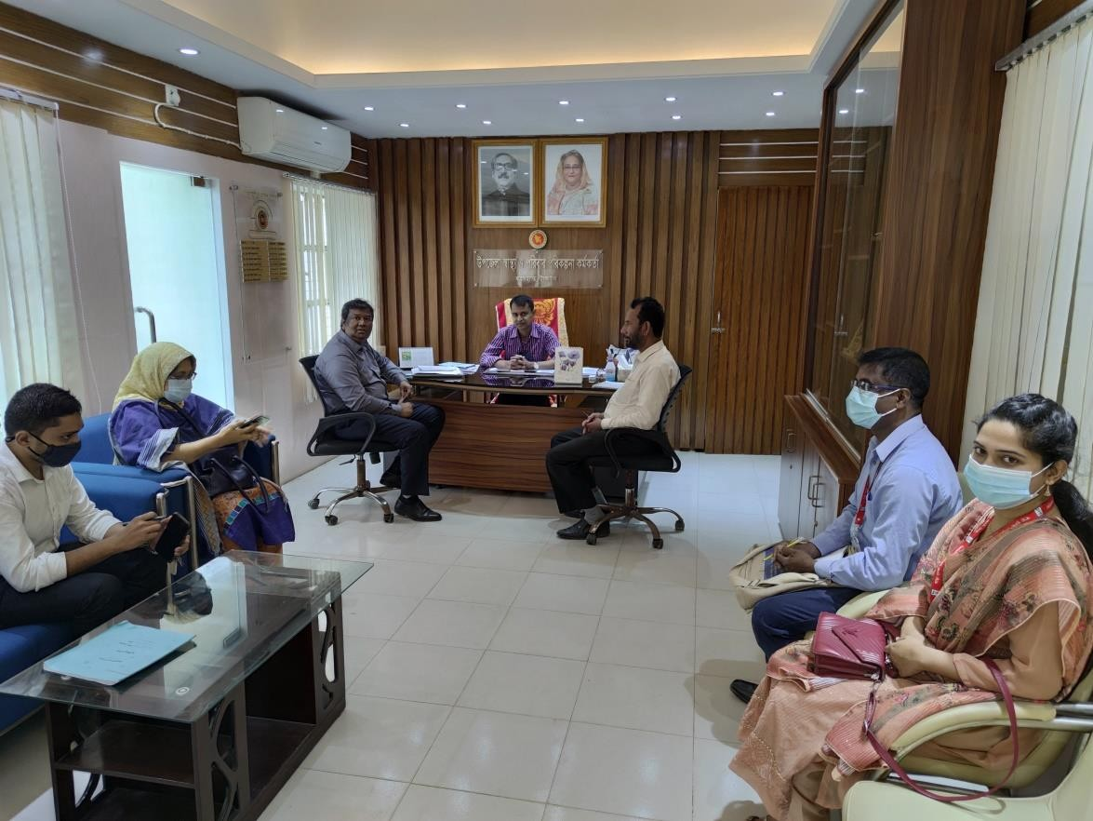

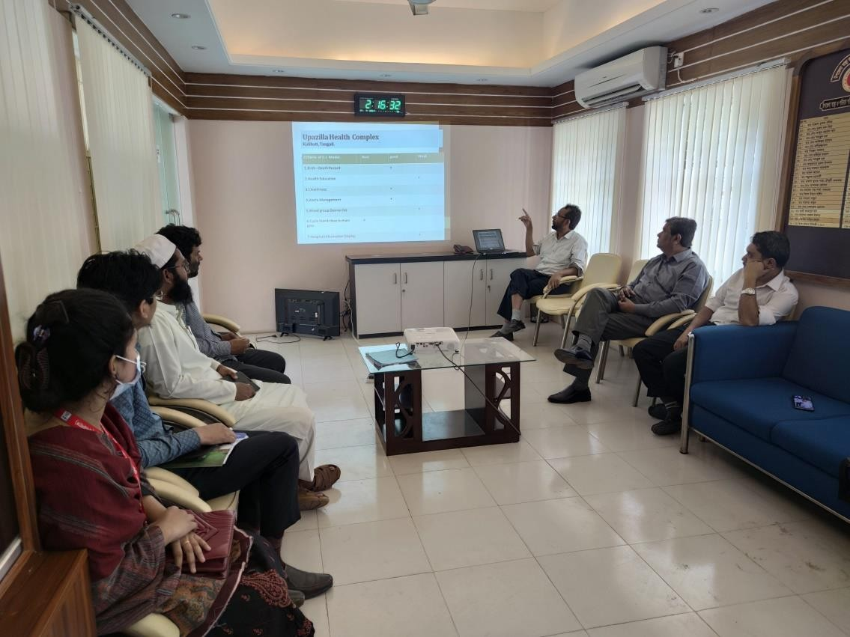
Meeting with UHFPO at Kalihati UHC

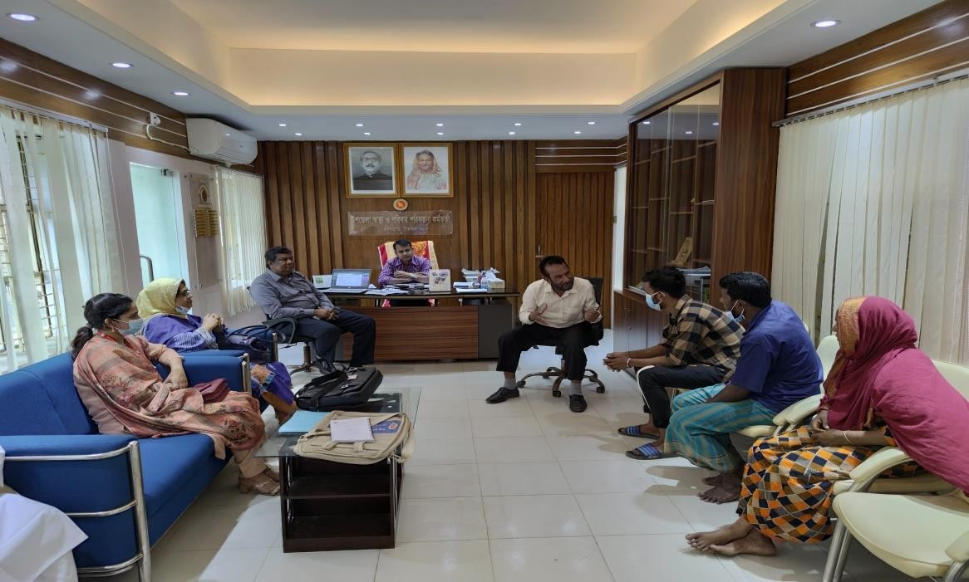

Dr. Md. Emdadul Haque trying to convince a SSK household who was not interested to conduct the cesarean at Kalihati UHC, but finally they convinced and they a boy child.

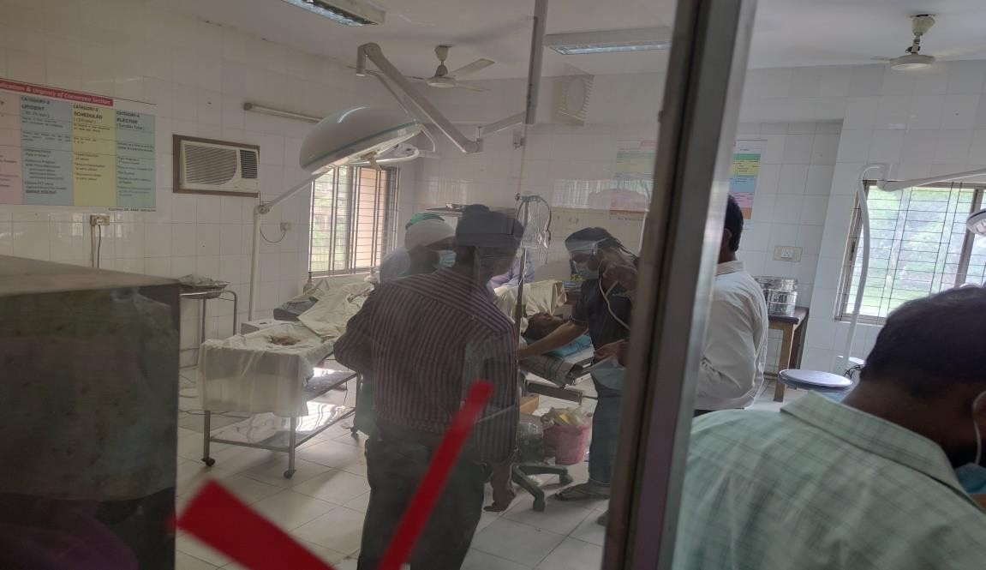
Cesarean going on

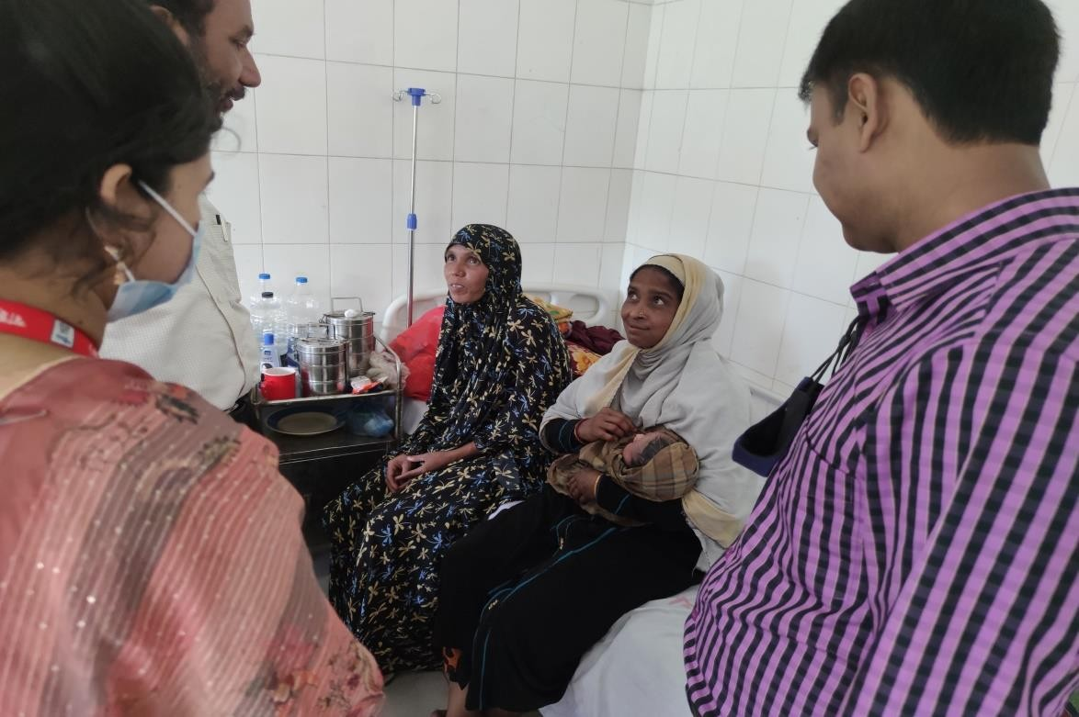
They are happy now!!!

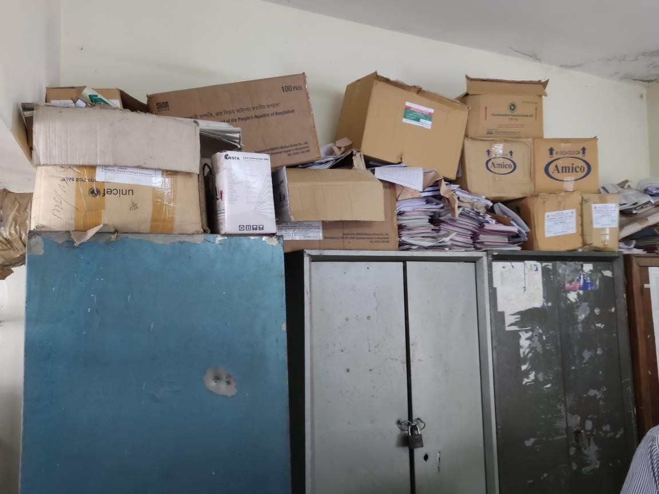

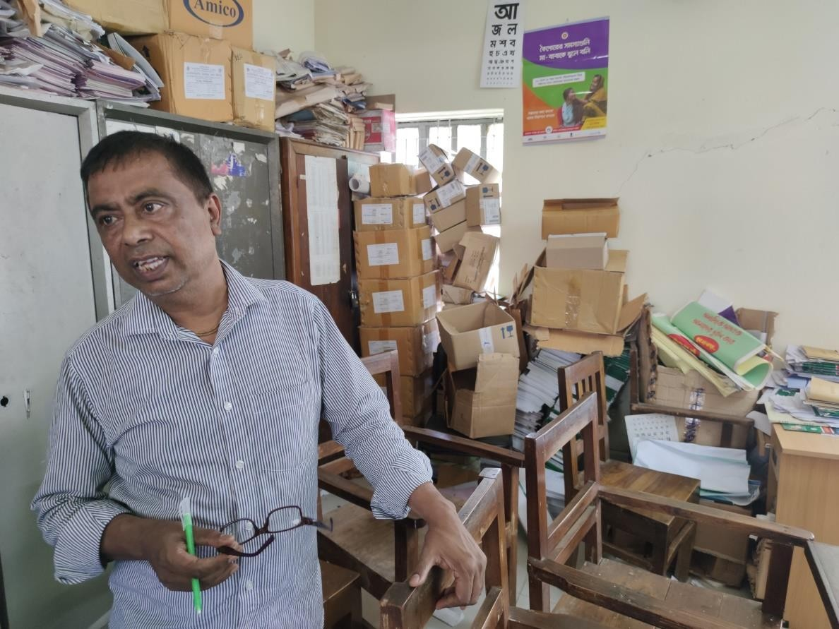

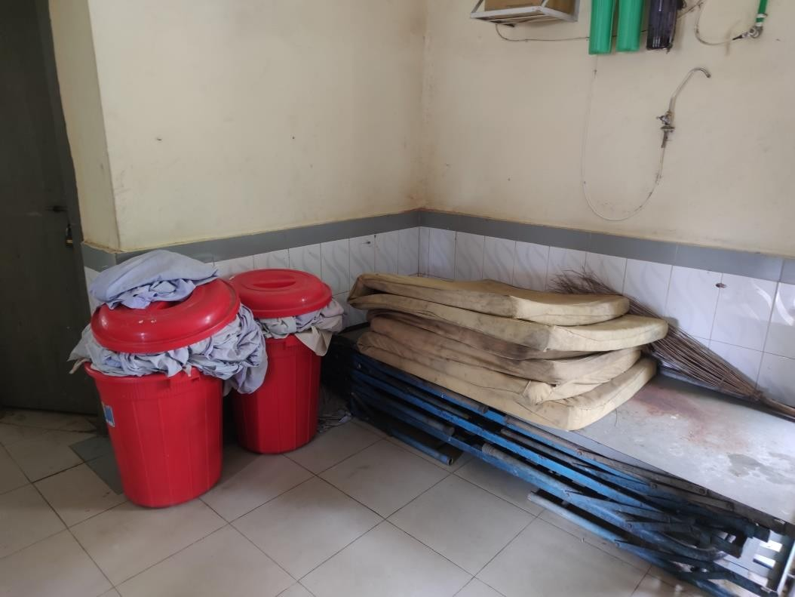
5S training is needed

A comparison of the Criteria Chowgacha UHC model with Kalihati UHC.

Sl.No. | Criteria of Chowgacha Model | Very good | Good | Poor
1. | Birth &Death recording |  | +
2. | Health education Corner. |  | +
3. | Cleanliness & Beatification |  | +
4. | Cycle-Van stand close to the main  gate. |  | +
5. | Display of the activities of the UHC (Field &health complex.) |  |  | +
6. | Blood donor list in Pathology dept |  |  | +
7. | Separation of patient in OPD  &IPD(Male,Female,Under5 & EOC) |  | +
8. | IMCI-Corner. |  | +
9. | ANC&PNC Corner |  | +
10. | NCD-Corner |  | +
11. | EPI & Breast Feeding Corner |  |  | +
12. | ORT &Nutrition Corner |  |  | +
13. | Waste management |  | +
14. | Moral based environment |  | +
15. | Implementation of 5S KAIZEN |  |  | +
16. | Community participation |  |  | +
17. | Reception Desk | +
18. | Hospital Protocol board. |  |  | +
19. | Display of meeting schedule |  |  | +
20. | Knowledge about 7th 5 yr. plan &  SDG. |  |  | +
21. | Display of information in every  section |  |  | +
22. | VIA Service |  | +
23. | Infection prevention activities. |  | +
24. | Relation with local community  leaders. |  | +
25. | Positive media coverage |  | +
26. | Publication of Annual Report. |  |  | +
27. | Position in HSS score of MIS inFeb-  22. | 39th
28 | Video on UHC. |  |  | +

Name of Hospital: UHC Mirzapur, Tangail

Date of Baseline assessment: 06/04/22.AT 11-30AM Assessment Team members:
Sl. | Name | Designation
1. | Mr.Azmal Kabir. | National Consultant (SSK)
2. | Dr. Md. Emdadul Haque. | National Consultant (SSK)

1.Admistrative discussion: Discussion with Dr. Faridul Islam, UH&FPO Mirzapur about basic information of the UHC and activities of SSK program .The hospital 31 bedded .According to the status of HSS score the position of Mirzapur UHC is 198th among 422 UHC of the country in Feb-22.
- Visit of the emergency, outdoor & indoor: We visited the hospital campus with UH&FPO and RMO

  - Campus was clean &beautiful. No Cycle stand is close to the main gate.
  - Emergency management system is effective. Lab service is well organized and running effectively.
  - Outdoor service is disorganized. There is no health education system.
  - Indoor: Effective labour word, Anesthesiologist and gynecologist post is fulfill.
** We visit to a union of Mirzapur to meet with the Data Collector and upazilla coordinator Mr Razu of SSK was present with us.
- Conclusions: The activities of the health complex are not so good but need more interventions.

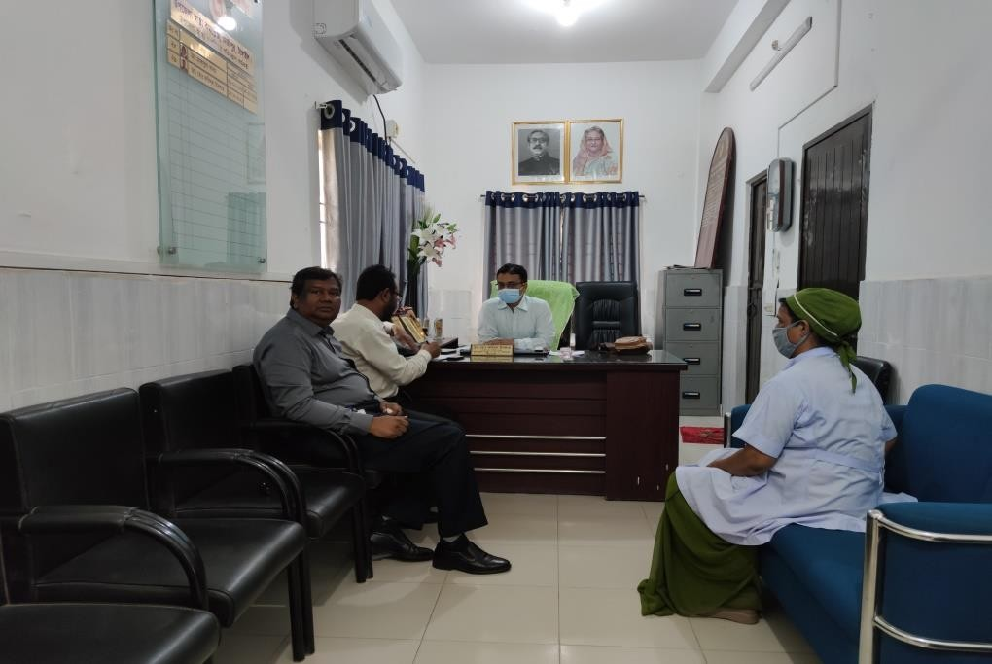

Meeting with UHFPO at Mirzapur

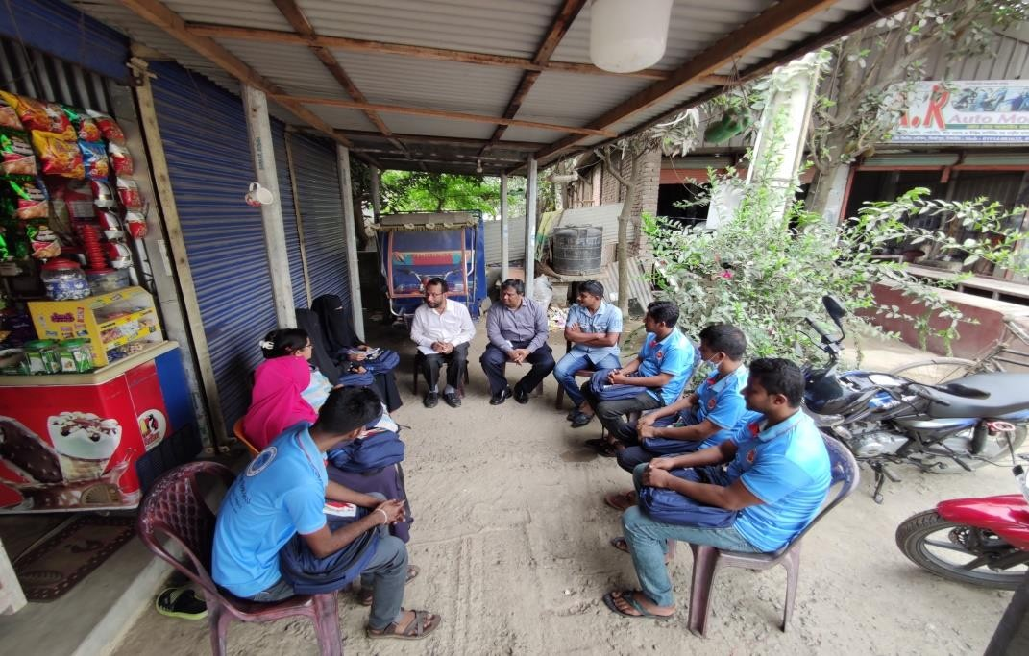
Meeting with BPL data collector at Mirzapur Pourashava

A comparison of the Criteria Chowgacha UHC Model with UHC.

Sl.No. | Criteria of Chowgacha Model | Very good | Good | Poor
1. | Birth &Death recording |  | +
2. | Health education Corner. |  |  | +
3. | Cleanliness & Beatification |  | +
4. | Cycle-Van stand close to the main  gate. |  |  | =
5. | Display of the activities of the UHC  (Field &health complex.) |  |  | +
6. | Blood donor list in Pathology dept. |  |  | +
7. | Separation of patient in OPD  &IPD(Male,Female,Under5 & EOC) |  | +
8. | IMCI-Corner. |  | +
9. | ANC&PNC Corner |  | +
10. | NCD-Corner |  | +
11. | EPI & Breast Feeding Corner |  |  | +
12. | ORT &Nutrition Corner |  |  | +
13. | Waste management |  | +
14. | Moral based environment. |  | +
15. | Implementation of 5S KAIZEN |  | +
16. | Community participation |  |  | +
17. | Reception Desk | +
18. | Hospital Protocol board. |  |  | +
19. | Display of meeting schedule |  |  | +
20. | Knowledge about 7th5 yr. plan & SDG. |  |  | +
21. | Display of information in every section |  |  | +
22. | VIA Service |  | +
23. | Infection prevention activities. |  | +
24. | Relation with local administration,  OC & community leaders. |  | +
25. | Positive media coverage |  | +
26. | Publication of Annual Report. |  |  | +
27. | Position in HSS score of MIS in Feb-  22 |  | 198th | +
28 | Video on UHC. |  |  | +

